Digital Lesson Plans: Honors World Lit.
- Continue with Weekly Vocabulary lessons – One a week
- Continue with flipped Grammar- Videos and Worksheets- can submit via photo and post to Schoology.
- Novel Reading Plan-Expected weekly chapters read will be posted on Schoology and sent in remind. Students will need a copy of A Thousand Splendid Suns by Khaled Hosseini
- Weekly Mini-lesson connected to Novel study will be posted on Schoology: Dated Weekly Folders will be posted for that week’s agenda and assignments due.
- Comcast is offering free internet over the next two months for low-income families. https://www.internetessentials.com/.

Weekly Plan for Digital Learning
Monday | Tuesday | Wednesday | Thursday | Friday
Vocabulary Enhancement:  Student will go onto Townsend Press and access the weekly assignments:  Words in Context  Matching Definitions  Sentence Check 1  Writing Sentences  Unit Test- This can be done same day but not due until Friday.  Townsend Press can be used on a computer or phone.  Assigned Reading  A Thousand Splendid Suns -assigned reading | Grammar Mini-lesson  Via Flipped Video-Videos will be on Schoology and sent out to all student in the remind.  A Grammar worksheet will be posted on Schoology and or a picture sent in remind if needed-  If students can’t print, they can write their answers on their own paper and submit via photo sent to me in remind or post on Schoology.  Assigned Reading  A Thousand Splendid Suns -assigned reading | Novel study  Mini Lesson via one of the following: flipped video  Screen-cast-Omatic  Step by step directions.  Video lessons will be sent in the remind and posted on Schoology.  Assignments will be posted on Schoology with due dates. Most due dates for Wednesday will be Friday.  Assigned Reading  A Thousand Splendid Suns -assigned reading | Work Day- on Novel Study Mini-lesson from Wednesday  Due dates will most  Likely be on Fridays-adjusted as needed  Assigned Reading  A Thousand Splendid Suns -assigned reading | Work Day- on Novel Study Mini-lesson from Wednesday  Assignment due: unless otherwise stated.  Novel Discussion day via Schoology or Remind.  Online Vocab Test due (from Townsend Press)  Assigned Reading  A Thousand Splendid Suns -assigned reading
Ways to hand in assignments:
- If a student has internet access, assignments will be submitted on Schoology in the “Weekly Folder.” Weekly folders will be added to Schoology and will be labeled with the dates for each week.
- If student only has phone access, they can still access Schoology, or send items as a text to me in remind by taking a picture of the finished assignment. They can also, use their phone to see assignments, and record their answers on their own paper. Make sure papers have Your name, date and title of the assignment on them prior to sending the image. If it goes to back, please add your name to the back as well.
Guidelines for Using Schoology
2ND BLOCK Honors World Lit.
Joining Schoology:
- Create an account at www.schoology.com by clicking “Sign-Up” and then selecting student.
- Submit the correct CASE SENSITVE access code: JNXH-GB4H6R796
- Continue following the prompts by signing up with your gmail account. If you do not have a gmail account, then you need to create one today.
- Next to your name in the upper right hand corner, click on the down arrow, then click on Notifications: Make sure all Mobile Notifications or turned ON. You can choose if you would like to have email notifications.
- Download the Schoology app to your phone.

Connecting Google Drive to Schoology:
- Click on “courses at the top of the page. Select “ 2nd block American Lit. spring 2019” block ___”
- Go back up to the top of page and click “resources” and click “apps”
- Look at the “My Resources Apps” section. Click the “install apps.” Scroll down and click on the “google drive” link.
Schoology will ask you to “approve” your Google Drive Account. Simply log in to your Google account to access Drive. If you have a Google email ( which you do) then you already have Drive.

Join Remind:
Remind.com/join/amkp2020
Text the message @amkp2020 to the number 81010

Townsend Press
Access: Sign-up

We will be using the digital platform for our same weekly vocabulary assignments. Please create an account and join my class as follows:

- Go to Townsend Press (google the name or https://www.townsendpress.net/ )
- In the middle of the screen click “Create Account”
- Select “Create Student Account”
- Complete the requested information with your information. DO NOT USE A NICK NAME I NEED IT TO BE YOUR FIRST NAME.
- You can sign-up with a user name or email. Choose your option:
My user name is ____________________________

My Password is ____________________________

- Complete the drop down menus as pictured below:
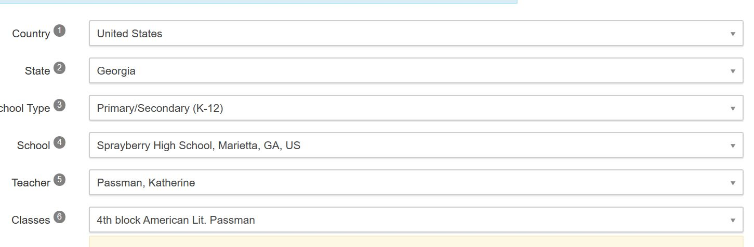
Honors World Lit Passman

- Click “Create Account”
- Assignments can be accessed from the home page.

